TOP-7 INDUSTRIAL AND LOGISTICS PROPERTY MARKETS 1st HALF of 2022
Shortage of space and building costs push up rents for logistics properties
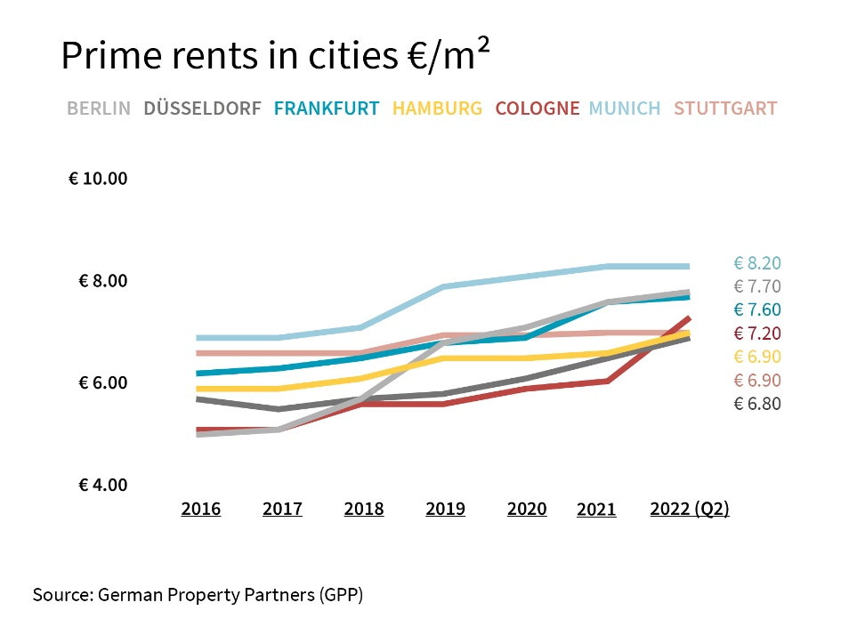

2022-06-20, Hamburg. The difficult economic environment is also affecting the market for industrial and logistics properties in Germany’s top 7 cities. “A shortage of raw materials, rising energy prices and disrupted supply chains have a negative effect on demand for manufacturing and logistics premises. Despite this, demand remains good overall,” reports Andreas Rehberg, spokesperson for the commercial real estate network German Property Partners (GPP). Indeed, the present state of affairs has brought fresh impetus to some cities. He adds that, “In the Stuttgart area, for example, we note brisk demand for properties in which manufacturing companies can store raw materials and thus become independent of unpredictable supply chains. Some enterprises, such as car makers and pharmaceutical firms are investing more heavily in manufacturing facilities in certain cities, thus generating a need for new sites.”

GPP’s member firms Anteon Immobilien, E & G Real Estate, GREIF & CONTZEN Immobilien and Grossmann & Berger have compiled fact sheets that provide an overview of past and present premium rent rates, land prices and prime yields in Germany’s top 7 locations.

RENTS and land prices continue to rise
During the first half of 2022 a severe shortage of building land plus higher construction costs resulted in rental increases, some of which were considerable, in five of the top 7 cities. This was especially true of logistics properties in and around Cologne, where the premium rent rose by more than 20 % year on year to €7.20/m²/month. In the environs of Hamburg premium rents also rose appreciably, climbing some 15 % to €6.00/m²/month. Rents for properties inside the city limits of Stuttgart and Munich stagnated at the previous year’s level. Munich is nevertheless the most expensive of the top 7 cities, commanding top rents of €8.20/m²/month in the city and €7.10/m²/month in the environs.

The shortage of space is apparent as soon as developers set out to buy land, and the potential for erecting new-builds is thus limited. Prices for commercial building land continue to rise or at least persist at the high levels seen a year ago. In and around Düsseldorf, for example, land prices have risen by between 11 and 14 % in the city and its immediate environs, and by between 25 and 33 % in the greater metropolitan area.

Investors with deep pockets have the edge
Industrial and logistics properties remain popular with investors. In the 1st half year GPP’s experts noticed that many top logistics properties were delivering lower yields than at the end of the previous year. Yields fell most steeply in Düsseldorf, dropping 0.40 percentage points to 3.15 %. However, the recent rise in interest rates will act to stop yields dropping further and will reduce the profitability of investments. Cash-rich investors are therefore at an advantage. “Recently we have seen some very high asking prices and, increasingly, these are being queried during sales negotiations,” says Rehberg. He adds, “In some locations we expect to find certain types of investment starting to deliver higher yields.”

FORECAST: Demand likely to remain high
It is hard to predict how the market will develop in the second half of the year in view of so many different risk factors, such as the war in Ukraine, inflation and the pandemic. “Provided that in 2022 the economy grows as forecast by the experts, demand for space is likely to continue to outpace availability and keep rental rates high”, Rehberg predicts. “Major issues such as electric vehicles, the “energy turnaround” and digitalization continue to affect a variety of industries and are sparking plans to re-structure, relocate or construct a new-build. The trend towards ever more online shopping will continue, and create demand for more space.”

You may download the Fact Sheet on the top 7 industrial and logistics real estate markets, i.e. Hamburg, Berlin, Düsseldorf, Cologne, Frankfurt, Stuttgart and Munich, from our website.

ABOUT GERMAN PROPERTY PARTNERS
German Property Partners is a national network of property service providers; they are all leaders in their local markets. Membership now consists of Grossmann & Berger, Anteon Immobilien, GREIF & CONTZEN Immobilien, blackolive and E & G Real Estate. The network is remarkable for the members’ intimate knowledge of local markets, the experience of the partner firms’ long-standing property consultants and the personal dedication of the owners and directors.

In Germany’s top 7 cities - Hamburg, Berlin, Düsseldorf, Cologne | Bonn, Frankfurt, Stuttgart and Munich - network partners have their own offices offering services in the field of property investment, commercial letting, corporate real estate management (CREM), property valuation and research. Rounding off the range of skills are banking, finance and administration services.

Currently, more than 420 property specialists work for the network. Nationwide, German Property Partners brokered lets in 2021 involving 640,000 m² of commercial property, and managed investment transactions totalling €2.6bn.

www.germanpropertypartners.de
German Property Partners’ data protection declaration is available on the GPP website: www.germanpropertypartners.de/en/privacy-policy. If in future you would prefer not to receive any more information from the GPP press office, please e-mail us at presse@germanpropertypartners.de quoting as reference "Abmeldung aus Presseverteiler” / “Unsubscribe from press mailing list”.

