TOP 7 INDUSTRIAL AND LOGISTICS PROPERTY MARKETS
Booming logistics market calls for greater flexibility

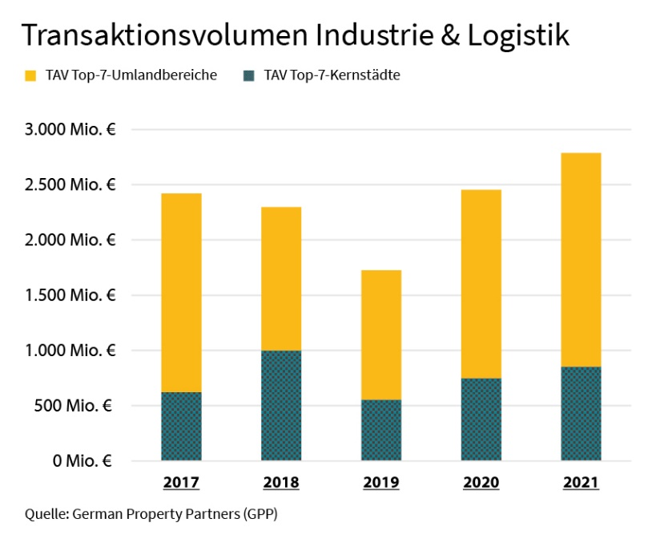

The environs of the top 7 cities account for an increasingly high proportion of overall investment activity.

23 February 2022, Hamburg. In 2021, the second year of the pandemic, there was a veritable run on industrial and logistics properties. The volume of transactions in this sector of the top 7 cities’ markets was about €2.79bn, the highest figure on record. Lettings also posted a new high with take-up of space at 3.42m square metres. However, the enormous demand for industrial and logistics properties is by no means matched by the dwindling supply. Building land for new developments and existing properties for letting are becoming scarce, creating a shortage of suitable assets for capital investors. “If investors wish to put money into this class of asset, they must be flexible in terms of location and size of the real estate they buy,” says Andreas Rehberg, spokesperson for the commercial property network German Property Partners (GPP). Membership now consists of Grossmann & Berger, Anteon Immobilien, GREIF & CONTZEN Immobilien, blackolive and E & G Real Estate.

How will the investment and letting markets develop in 2022 given the shortage of properties? Where are the opportunities for tenants and investors?

Investment Market: Interest remains high
In most of the top 7 cities the trading volume grew appreciably in 2021. The exceptions are Frankfurt and Munich due to the limited amount on offer. “Investor interest in industrial and logistics real estate is enormous, and interest rates remain favourable. Properties in good locations let to tenants with excellent credit ratings are highly sought-after. High demand and the likelihood that rents will rise offer investors the prospects of a good cash flow,” says Rehberg. The limiting factor was and is the amount of real estate available. With properties in short supply, an increasing number of investors are turning to real estate in neighbouring communities and on the periphery of the logistics regions. “Thus there will be growing opportunities to market existing properties, development land and brownfield sites,” forecasts Rehberg. Last year the dearth of properties for sale pushed land prices up and prime yields down (to an average of 3.34 %). Real estate experts expect to see these trends continue during the current year. Rehberg remarks that, “Since there are so few alternative investments, competition for highly sought-after logistics properties will become even fiercer in 2022. Ever greater numbers of investors who used to concentrate on other types of real estate are discovering the appeal of logistics properties.”

Letting market: Shortage of space and rising rents
The logistics and online retailing sectors were instrumental in fuelling demand for commercial space during the pandemic. However, the amount of space available for letting - whether already standing or in a new-build - has not grown as fast as demand. In various cities new-builds and revitalization projects were completed last year. But sometimes these projects had taken years of planning, so that it was not possible to increase the amount of available space short-term. In Cologne, for example, units offering 1,000 m² or more are hard to find, in Stuttgart and Hamburg premises larger than about 3,000 m² are in short supply. Clients have to widen the area they search to find new premises. “Economic forecasts indicate that business will continue to revive, and this will exacerbate the mismatch between supply and demand. Since supply will not expand, clients will increasingly have to consider B and C locations or existing buildings that can be redeveloped,” says Rehberg. In view of the shortage of land, buildings that unlock more potential including, for example, multi-storey halls, are attracting the attention of market players. Across the board, the lack of space led to rising premium rents in the cities and their environs in 2021. This trend will continue in 2022.

You may download the full version of our Market Survey of the industrial and logistics property markets in Hamburg, Berlin, Düsseldorf, Cologne, Frankfurt, Stuttgart and Munich from our website.

ABOUT GERMAN PROPERTY PARTNERS
German Property Partners is a national network of property service providers; they are all leaders in their local markets. Membership now consists of Grossmann & Berger, Anteon Immobilien, GREIF & CONTZEN Immobilien, blackolive and E & G Real Estate. The network is remarkable for the members’ intimate knowledge of local markets, the experience of the partner firms’ long-standing property consultants and the personal dedication of the owners and directors.

In Germany’s top 7 cities - Hamburg, Berlin, Düsseldorf, Cologne | Bonn, Frankfurt, Stuttgart and Munich - network partners have their own offices offering services in the field of property investment, commercial letting, corporate real estate management (CREM), property valuation and research. Rounding off the range of skills are banking, finance and administration services.

Currently, more than 410 property specialists work for the network. Nationwide, German Property Partners brokered lets in 2020 involving 462,800 m² of commercial property, and managed investment transactions totalling €2.45bn.

www.germanpropertypartners.de/en

German Property Partners’ DATA PROTECTION DECLARATION is available on the GPP website: www.germanpropertypartners.de/en/privacy-policy. If in future you would prefer not to receive any more information from the GPP press office, please e-mail us at presse@germanpropertypartners.de quoting as reference "Abmeldung aus Presseverteiler” / “Unsubscribe from press mailing list”.

