TOP 7 PROPERTY MARKETS FOR INDUSTRY AND LOGISTICS
Plenty of chances despite obstacles
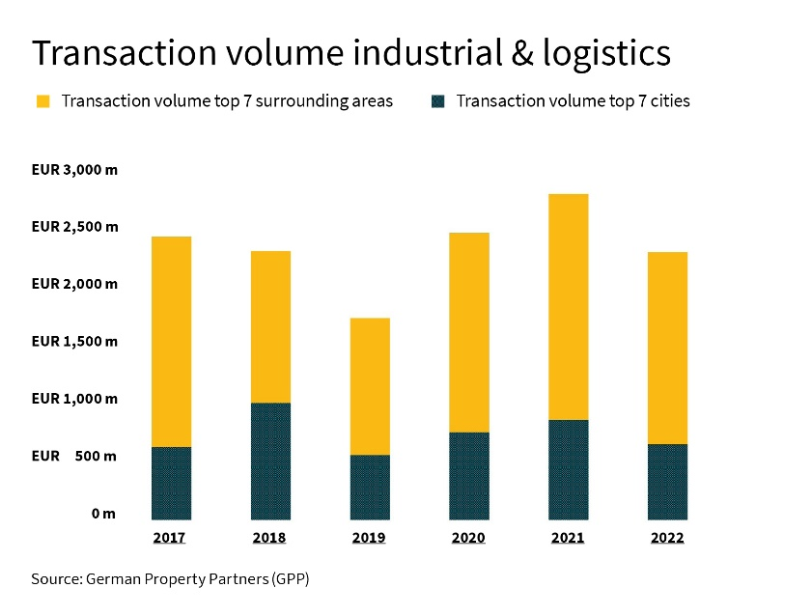
Hamburg, 14 February 2023. There is a continuing demand for industrial and logistics property among users and investors, although sales in the Top 7 locations declined last year due to reduced availability and the interest rate reversal. The take-up of space in the rental market, for instance, fell by an average of 19 % compared to the previous year’s record result of around 2.8 mill. m². The Top 7 transaction volume for industrial and logistics property was around 2.29 billion € and therefore below the previous year’s level (-18 %); it was also slightly lower than the five-year average of 2.33 billion €. Nevertheless, Andreas Rehberg, spokesman of German Property Partners (GPP) – a national network of commercial property service providers – is convinced that “Because of excess demand and rising rents, industrial and logistics sites remain extremely attractive as an asset class.”

The members of the broker network are Grossmann & Berger, Anteon Immobilien, GREIF & CONTZEN Immobilien, blackolive and E & G Real Estate.

THE RENTAL MARKET: SHORTAGE OF SPACE AS A LIMITING FACTOR
The take-up of space in the rental market was limited by restricted availability. Only Berlin (+24 %) and Stuttgart (+2 %) were able to exceed the previous year’s figure. Nevertheless, the Top 7 result (2.79 mill. m²) corresponds approximately to the five-year average of 2.73 mill. m². The low level of unoccupied property throughout the country led to a further rise in top rents: Cologne, Hamburg, Düsseldorf and Stuttgart reached growth rates of 14 % to 34 %. Nevertheless, at 8.60 €/m²/month in the urban area, Munich remained the leader among the Top 7. In the longer term, too, the shortage of space and high building costs may result in further rent increases in some locations.

DEMAND WILL CONTINUE TO EXCEED AVAILABILITY
Rehberg: “The year started with good demand for space in several markets. Although economic uncertainty and limited availability are curbing the potential uptake of space, this is unlikely to have far-reaching consequences for the industrial and logistics market as a whole.” According to forecasts, the recession will be only moderate, and a recovery is to be expected in the second half of the year. However, risk factors do remain in the shape of further developments in the Ukraine war, inflation, and the supply situation for energy, raw materials and construction resources.

the interest rate reversal IS WEIGHING ON the investment market for industrial and logistics property
Last year, many investors assumed a wait-and-see attitude because of the massively worsened financing terms. The gap in price expectations between sellers and buyers widened significantly; some transactions were broken off. This reticence is also reflected in the transaction volume. Except for Cologne and Frankfurt, the Top 7 locations showed a considerable decline in sales as compared to the previous year. Rehberg: “In the second half of the year, some sales took place nevertheless; that goes to show that many investors still consider this asset class lucrative. However, sellers are having to accept considerable markdowns compared to the former price level.” The focus of demand has shifted too, Rehberg says: “Buyers want their investments to generate more profitability, because they are paying higher interest on loans and many have to utilize more of their capital than in the past. So investor interest is focussing on properties that fall into the risk classes Value-Add or at least Core Plus. There is less demand for mere Core products.”

In most locations, land prices have risen in both the urban areas and their environs, but the extent differs from one region to another. At +67 % compared to the year before, the rise to a present 600 €/m² was especially noticeable in Düsseldorf. Nevertheless, at 800 €/m² Munich remains the most expensive location. The top yields have also risen appreciably due to last year’s price markdowns (on average by +0.50 percentage points to 3.83 %), and they may continue to rise in future.

STILL POTENTIAL FOR INVESTORS
“If the interest rate environment permits greater planning security, investment activities will increase noticeably again, too. That is likely to be the case by the middle of the year”, Rehberg forecasts. On the basis of various factors, he considers the prospects for the future of this asset class to be largely positive: “Owners and investors are benefiting from the nationwide scarcity of available space; there is very little unoccupied property, and modern spaces, especially, are finding users. Moreover, the greatly increased rents and widespread index-linked rental agreements offer investors security.” In the logistics segment, especially, users are able to pass the high rent costs on to the next stages of the value chain, or to consumers. And finally, reduced competition offers chances for investors with a solid capital base.

The detailed market report for Hamburg, Berlin, Düsseldorf, Cologne, Frankfurt, Stuttgart and Munich can be downloaded from our website.

ABOUT GERMAN PROPERTY PARTNERS
German Property Partners is a national network of property service providers; they are all leaders in their local markets. Membership now consists of Grossmann & Berger, Anteon Immobilien, GREIF & CONTZEN Immobilien, blackolive and E & G Real Estate. The network is remarkable for the members’ intimate knowledge of local markets, the experience of the partner firms’ long-standing property consultants and the personal dedication of the owners and directors.

In Germany’s top 7 cities - Hamburg, Berlin, Düsseldorf, Cologne | Bonn, Frankfurt, Stuttgart and Munich - network partners have their own offices offering services in the field of property investment, commercial letting, corporate real estate management (CREM), property valuation and research. Rounding off the range of skills are banking, finance and administration services.

Currently, more than 420 property specialists work for the network. Nationwide, German Property Partners brokered lets in 2022 involving 580,000 m² of commercial property, and managed investment transactions totalling €1.5bn.
www.germanpropertypartners.de

German Property Partners’ data protection declaration is available on the GPP website: www.germanpropertypartners.de/datenschutz. If in future you would prefer not to receive any more information from the GPP press office, please e-mail us at presse@germanpropertypartners.de quoting as reference "Abmeldung aus Presseverteiler” / “Unsubscribe from press mailing list”.

