TOP 7 OFFICE MARKETS Q3/2021
Releasing the brakes

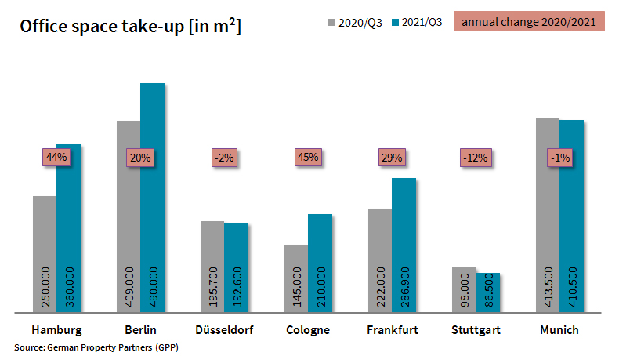

05 October 2021, Hamburg. In the 3rd quarter companies based in Germany’s top 7 cities became far more willing to sign rental agreements or start construction of their own premises, generating take-up of 824,600 m² of office space. In Hamburg, Berlin, Düsseldorf, Cologne, Frankfurt, Stuttgart and Munich take-up of office space during the first three quarters totalled 2.04m square metres. A year on year increase of 17 % took the total past the two-million-square-metres mark. “Results to date and the brisker activity that is expected in the fourth quarter nourish the hope that by and large take-up for the entire year will be satisfactory” says Oliver Schön, spokesperson for German Property Partners (GPP) in his summary of the situation in Germany’s top 7 cities. Partner firms in the GPP commercial property network are Grossmann & Berger, Anteon Immobilien, GREIF & CONTZEN Immobilien, blackolive and E & G Real Estate .

DEMAND IN ALL LOCATIONS
Compared with the situation in the preceding quarter, when year on year take-up figures in the top 7 ranged from -35 % to +52 %, the gap narrowed in the 3rd quarter to between -12 % and +45 %. Just as in the 2nd quarter, results rose in Cologne, Hamburg, Frankfurt and Berlin but fell in Munich, Düsseldorf and Stuttgart. “Cologne, for example, posted the highest growth rate, to pull slightly ahead of its pre-pandemic total. Berlin, however, matched the figures for 2019 only in terms of the number of agreements signed. However, considering that no agreements for office suites larger than 5,000 square metres were signed, it was an achievement to post year on year growth of one-fifth,” remarks Schön. A positive development in Stuttgart, where the steepest drop in take-up was noted, is the newly increased number of agreements, especially for small and mid-sized office suites. “Whereas industrial enterprises used to dominate demand for space in the south, their place has now been taken by IT and telecommunications firms. In view of plateauing new orders and supply bottlenecks although order books are still full, the ifo business confidence index has noted the third successive downturn in the mood of manufacturing company managers. Therefore it remains to be seen when industry regains the pole position in the south,” says Schön.

offices remain part of the working scene
At the end of the 3rd quarter, despite the upheavals in how people go about their work and the feared rise in company insolvencies, the vacancy rate in Germany’s top 7 cities was still moderate at 4.3 % compared with 3.2 % a year ago. As expected, more space became available at short notice in each of Germany’s top 7 cities, with Munich, Berlin and Stuttgart posting the largest increases. The vacancy rate was lowest in the national capital at 2.7 % and highest in Frankfurt on Main at 8.3 %. “It would seem, however, that in terms of empty space, Frankfurt has turned the corner,” comments Schön. The number of sub-let agreements also remained far lower than feared. Schön notes that, “Instead of hastily vacating space in order to save rent for a short period, most companies are taking the longer view and examining the future viability of their business models.”

FORECAST: LARGE-VOLUME AGREEMENTS IN THE PIPELINE
In September the ifo employment barometer reached its highest level since October 2018, indicating further market recovery to come. This, combined with the observation that the 4th quarter is traditionally the busiest one, and the fact that talks to finalize agreements for large volumes of space in Berlin, Cologne and Stuttgart are in progress, a realistic forecast for the 4th quarter is between 700,000 and 900,000 m² of take-up. Therefore, the GPP forecasts a year-end total take-up of some 3.0m square metres. This would be well above the 2.5m square metres taken up by new tenants and owner-occupiers in the year dominated by the coronavirus but a long way from 2019, when take-up of 3.9m square metres was noted.

Major known agreements for 15,000 m² or more | Top 7 locations | Q1-3 2021
City | Project/property | Tenant/owner-occupier | Rental area (ca. m²)
MUC | Anzinger Strasse | Deutsches Patent- und Markenamt (Patents office, DPMA) | 45,000
BER | “Upbeat”, Heidestrasse | DKB Bank | 34,900
BER | “New Courts”, Gerichtstrasse 48-49 | Federal Office for Consumer Protection and Food Safety (BVL). | 20,000
FFM | “Kreisler”, Baseler Straße 46-48 | Nestlé Deutschland | 20,000
HAM | “Ipanema”, Überseering 30 | Berenberg Bank | 19,200
CGN | confidential | confidential | 19,000
MUC | Freisinger Landstrasse | SAP | 18,000
MUC | Gisela-Stein-Strasse | Wacker Chemie GmbH | 17,800
CGN | Josef-Lammerting-Allee 24-34 | Federal agency | 16,200
FFM | “The Move Blue”, Gateway Gardens,  De-Saint-Exupèry-Strasse 3, 5-7 | Siemens (owner-occupier) | 15,000
Transactions occurring in the quarter covered by this report are highlighted. Source: German Property Partners (GPP)

Top 7 cities | 1st-3rd quarters of 2021
 | HAM | BER | DUS | CGN | FFM | STU | MUC | Top 7
Take-up of space  in m² | 360,000 | 490,000 | 192,600 | 210,000 | 286,900 | 86,500 | 410,500 | 2,036,500
Change  against prior yr in % | +44 | +20 | -2 | +45 | +29 | -12 | -1 | +17
Premium rent  in €/m²/month | 31.50 | 38.50 | 28.50 | 26.00 | 46.00 | 25.00 | 39.00 | -
Average rent  in €/m²/month | 18.10 | 28.00 | 16.50 | 17.00 | 22.90 | 15.70 | 22.70 | -
Total stock of office space  in millions m² | 13.96 | 20.15 | 7.31 | 8.00 | 11.69 | 8.25 | 23.30 | 92.66
Vacant space incl. sub-let space [m²] | 536,700 | 550,000 | 541,200 | 275,000 | 966,900 | 269,500 | 850,000 | 3,989,300
Vacancy rate incl. sub-let space [%] | 3.8 | 2.7 | 7.4 | 3.4 | 8.3 | 3.3 | 3.6 | 4.3
Completions  2021 + 2022 in m² | 268,000 | 1,193,700 | 239,400 | 200,000 | 473,100 | 245,000 | 645,000 | 3,264,000
Pre-let ratios 2021 + 2022 in % | 69 | 55 | 73 | 70 | 53 | 74 | 62 | 61
Source: German Property Partners (GPP)

ABOUT GERMAN PROPERTY PARTNERS
German Property Partners is a national network of property service providers; they are all leaders in their local markets. Membership now consists of Grossmann & Berger, Anteon Immobilien, GREIF & CONTZEN Immobilien, blackolive and E & G Real Estate. The network is remarkable for the members’ intimate knowledge of local markets, the experience of the partner firms’ long-standing property consultants and the personal dedication of the owners and directors.

In Germany’s top 7 cities - Hamburg, Berlin, Düsseldorf, Cologne | Bonn, Frankfurt, Stuttgart and Munich - network partners have their own offices offering services in the field of property investment, commercial letting, corporate real estate management (CREM), property valuation and research. Rounding off the range of skills are banking, finance and administration services.

Currently, more than 410 property specialists work for the network. Nationwide, German Property Partners brokered lets in 2020 involving 462,800 m² of commercial property, and managed investment transactions totalling €2.45bn.

www.germanpropertypartners.de/en

German Property Partners’ data protection declaration is available on the GPP website: www.germanpropertypartners.de/en/privacy-policy. If in future you would prefer not to receive any more information from the GPP press office, please e-mail us at presse@germanpropertypartners.de quoting as reference "Abmeldung aus Presseverteiler” / “Unsubscribe from press mailing list”.

