GERMAN PROPERTY PARTNERS
Press contact:
Ms Britt Finke
Phone: +49 (0)40 / 350 80 2 - 993
Fax: +49 (0)40 / 350 80 2 - 36
Mobile: +49 (0)162 / 232 30 37
Mail: b.finke@grossmann-berger.de
PRESS RELEASE
GREIF & CONTZEN IS NEW NETWORK PARTNER

02 December 2015, Hamburg/Cologne. As of 1st January 2016 GREIF & CONTZEN Immobilien, whose registered office is in Cologne, will become a member of the German Property Partners (GPP) nationwide network of firms active in the commercial real estate industry. GPP is thus represented by partners based in the top 6 property business cities – Hamburg, Berlin, Düsseldorf, Stuttgart, Munich and Cologne. The partners in the property network established in September 2013 are ELLWANGER & GEIGER (Stuttgart, Munich), Grossmann & Berger (Hamburg, Berlin), ANTEON Immobilien (Düsseldorf) and the new addition GREIF & CONTZEN Immobilien (Cologne).

40 YEARS EXPERIENCE ON THE COLOGNE MARKET

For 40 years owner-managed GREIF & CONTZEN Immobilien has been providing consultancy, evaluation, brokering and management services for commercial and residential real estate in the metropolitan region of Cologne. More than 80 property specialists work for the enterprise, covering the entire value chain of the real estate business – from market analysis and consultancy for project developers to tailor-made marketing concepts and from carefully targeted broker’s services to facility management.

CLOSE TO 350 PROPERTY EXPERTS

“The decision of GREIF & CONTZEN Immobilien to join German Property Partners is an important milestone for the network,” says GPP spokesman Björn Holzwarth. “Mr Greif and his team run a well-established, highly regarded company and share our values, so they are a very good match for the GPP network which now numbers close to 350 property experts. We can therefore supply our clients not only with detailed knowledge of the location, but also a broader portfolio of commercial properties to buy or rent in the Cologne area.”

Theodor J. Greif, the managing partner of GREIF & CONTZEN Immobilien, adds, “In joining German Property Partners we have institutionalized our cooperation at national level. Firm partnerships with regional market leaders in Germany’s top locations will give us a greater and more active presence throughout the country.” 2,020 signs excluding main headlines

Permission is given to print the attached photo (source: GPP).

Photo caption: The management team of German Property Partners welcoming the new member GREIF & CONTZEN Immobilien. From left to right: Mario Caroli, ELLWANGER & GEIGER Privatbankiers, Guido Nabben, ANTEON Immobilien, GPP spokesman Björn Holzwarth, ELLWANGER & GEIGER, Theodor J. Greif, GREIF & CONTZEN Immobilien, Axel Steinbrinker, Grossmann & Berger, Jens Reich, ANTEON Immobilien, Lars Seidel, Grossmann & Berger, and Alexander Zigan, ELLWANGER & GEIGER.

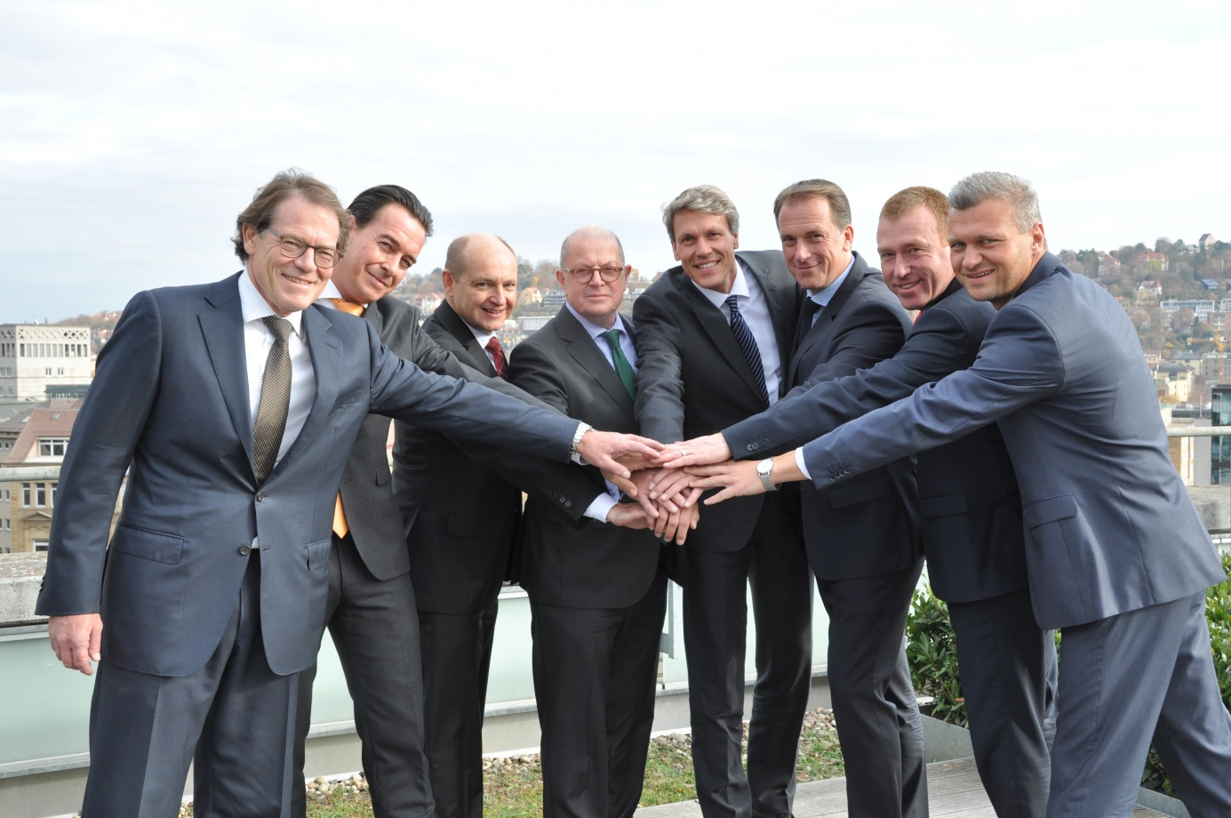

ABOUT GERMAN PROPERTY PARTNERS
German Property Partners is a national network of property service providers; they are all leaders in their local markets and have a banking background. The network is represented by offices in Hamburg, Berlin, Düsseldorf, Cologne, Frankfurt am Main, Stuttgart and Munich. It offers services in matters of property investment and commercial lets, in the property management business and research, plus banking, financial and administrative services. Currently 265 property experts act for German Property Partners; on average they have been in the network for ten years. Nationwide, German Property Partners brokered lets in 2014 involving 310,000 m² of commercial property and managed transactions totalling 610m €. [www.germanpropertypartners.de]

