GERMAN PROPERTY PARTNERS
PRESS CONTACT
Ms Britt Finke
Phone: +49 (0)40 / 350 80 2 - 993
Fax: +49 (0)40 / 350 80 2 - 36
Mobile: +49 (0)162 / 232 30 37
Mail: b.finke@grossmann-berger.de
PRESS RELEASE
BLACKOLIVE FIFTH PARTNER / NETWORK NOW PRESENT IN ALL TOP 7 LOCATIONS

03 March 2016, Hamburg/Frankfurt. The nationwide commercial real estate network German Property Partners (GPP) is now complete. On 1st March 2016 black olive advisors, registered office in Frankfurt am Main, joined the association of property consultants which thus now has a representative based in each of Germany’s top 7 locations.

The property network was founded in September 2013 with three partners, Grossmann & Berger (Hamburg, Berlin), ELLWANGER & GEIGER Real Estate (Stuttgart, Munich) and ANTEON Immobilien (Düsseldorf) and enlarged in January 2016 with the addition of GREIF & CONTZEN Immobilien (Cologne | Bonn).

Rainer Hamacher and Oliver Schön founded blackolive in 2012; this owner-manager services company focuses on real estate. The team has grown to 25 employees and, with more than 20 years of experience in the real estate industry, the firm specializes in consultancy, marketing and brokering commercial property lets and investment transactions in the Frankfurt region.

“A number of collaborative projects in the past has shown what a good match blackolive is for our partnership. Our new partners stand out for their independence, structured work processes, extremely good knowledge of the market, many years of experience and enthusiasm for people and properties,” says GPP spokesman Björn Holzwarth. “blackolive is now “our man in Frankfurt”, currently Germany’s prime real estate hot-spot, together with Berlin and Munich.”

“Since we established the firm, we have been looking to join a nationwide network with partners in similar positions and on the same wave-length as us. Our previous experience tells us how important an organized network is, particularly in the international investment business,” says blackolive managing director Oliver Schön explaining why the firm decided to join.

A total of more than 370 real estate specialists work in the GPP network; in 2015 they brokered some 410,000 m² of commercial space and were involved in transactions valued at €1.9bn.

1,965 signs excluding main headlines

Permission is given to print the attached photo (source: GPP).

Caption: The management team of German Property Partners welcomes new partner black olive advisors at their first working meeting in Cologne.

Left to right: GPP spokesman Björn Holzwarth (ELLWANGER & GEIGER Real Estate), Axel Steinbrinker (Grossmann & Berger), Rainer Hamacher (blackolive), Jens Reich (ANTEON Immobilien), Theodor J. Greif (GREIF & CONTZEN Immobilien), Guido Nabben (ANTEON Immobilien) and Marius Varro (ANTEON Immobilien).

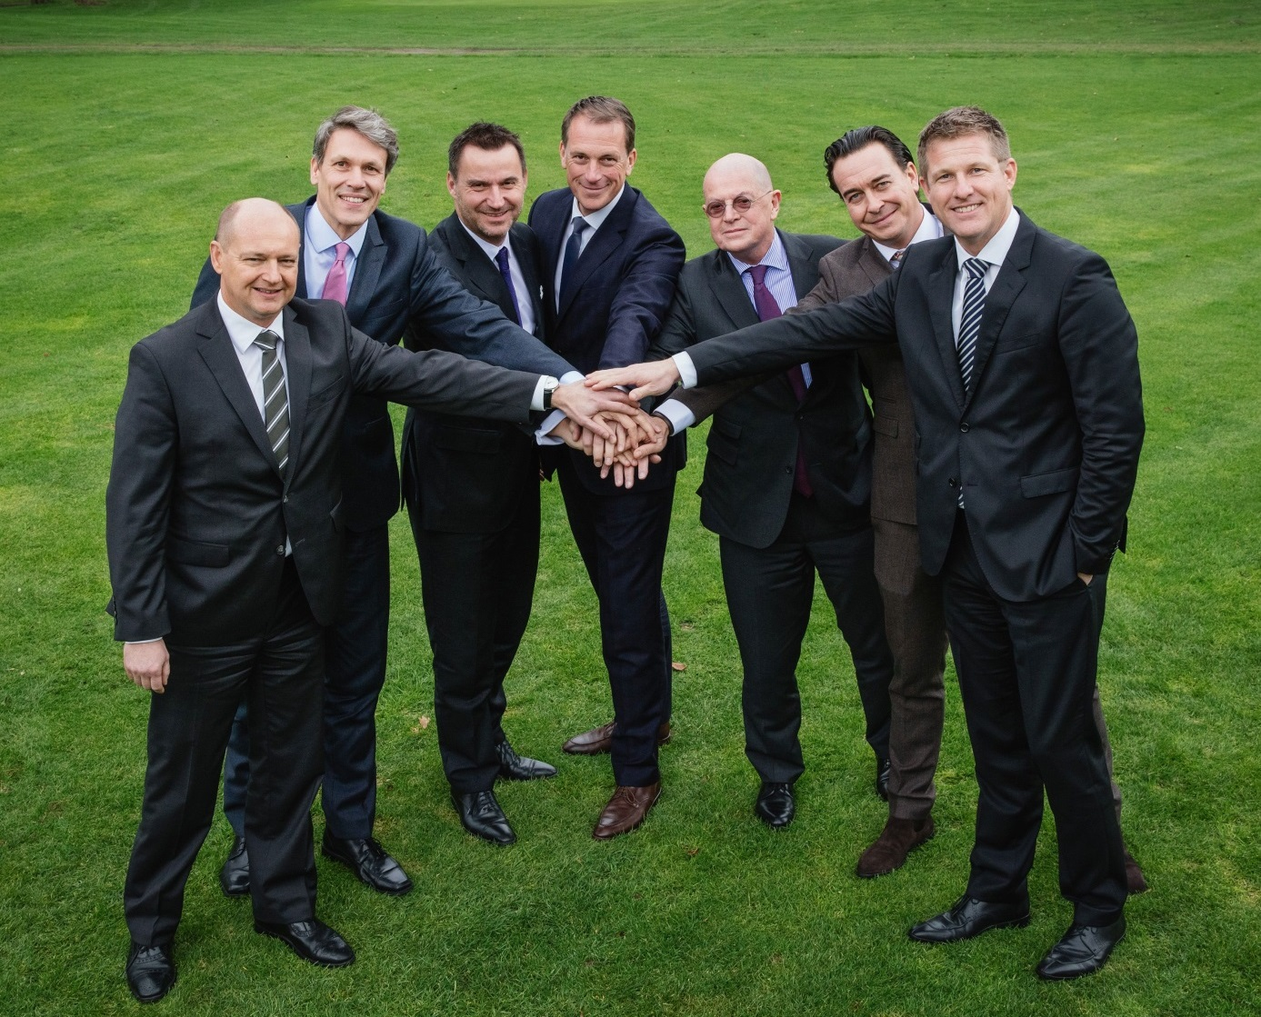

ABOUT GERMAN PROPERTY PARTNERS
German Property Partners is a nationwide network of property service providers which are leaders in their local markets. The network’s greatest strengths are in-depth knowledge of local markets, the long service history of the partner companies’ real estate consultants and the strong personal commitment of the owners and directors. The network is represented by offices in Hamburg, Berlin, Düsseldorf, Cologne | Bonn, Frankfurt, Stuttgart and Munich. It offers services in matters of property investment and commercial lets, in the property management, research and valuation business, plus banking, financial and administrative services. Currently more than 370 property experts act for German Property Partners. Nationwide, the network brokered lets in 2015 involving 410,000 m² of commercial property and managed transactions totaling €1.9bn. [www.germanpropertypartners.de]

