Hamburg: Retail space let
Grossmann & Berger brings Live Fast Die Young to Hamburg

Hamburg 3rd April 2022 – The streetwear brand LIVE FAST DIE YOUNG (LFDY) continues to pursue its expansion plans and will open a new store in Hamburg. The company has taken some 305 m² of shop space spread over two floors at Hohe Bleichen 13 in Hamburg’s Neustadt district. The building’s high-quality, minimalistic fit-out perfectly suits the low-key showroom style favoured by LFDY – which was founded in 2012 in Düsseldorf – and seen in its other stores in Amsterdam, Berlin, Cologne, Düsseldorf and Munich. LFDY likes to select specific items of clothing for presentation on huge screens. Known as the “X3”, the building features a 30-square-metre roof terrace which has been let exclusively to LFDY.

Hitherto, the shop space was occupied by the multi-brand boutique Petra Teufel which now operates in premises on Eppendorfer Landstrasse. Located in the ABC quarter, this office and commercial building designed by the architects Bothe Richter Teherani is owned by a real estate company and was completed in 2005. Grossmann & Berger, member of German Property Partners (GPP), brokered the rental agreement between the real estate company and LFDY.

LFDY produces power washed streetwear with large print designs. Most customers are men aged between 18 and 29. The label does not advertise in the classic sense, preferring to market its strictly limited editions to customers who buy from the online store or its bricks and mortar shops. Marco Reus, a football player, and Luciano, a rapper, are among LFDY’s customers.

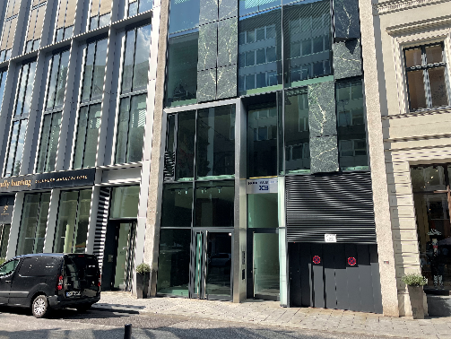 | Photo:  A premium neighbourhood, an exclusive roof terrace and superior fit-out are the hallmarks of the store located at Hohe Bleichen 13 in Hamburg’s ABC quarter.  Source: Matthias Schücking / Grossmann & Berger GmbH

Please consult our website for Grossmann & Berger’s data privacy policy. Here you will also be able to access our press kit and the associated Terms of Use. If in future you would prefer not to receive any more information from our press office, please e-mail us at presse@grossmann-berger.de quoting as reference "Abmeldung aus Presseverteiler” / “Unsubscribe from press mailing list”.

