Hamburg: Retail space let
Technogym, a manufacturer of fitness equipment, moving to Hamburg

Hamburg, 22 June 2022 — The fact that the operators of gyms and fitness studios like to take premises in the centre of large cities shows that health and fitness are now everyday essentials. Accordingly, this maker of exercise machines and sports equipment has decided to take space at Neuer Wall, an exclusive street in Hamburg’s Neustadt district. Through the agency of Grossmann & Berger, member of German Property Partners (GPP), the company found what it was looking for in number 77 Neuer Wall, opposite the Steigenberger Hotel and the “Stadthöfe” complex. The shop floor measures some 110 m² and the floor-to-ceiling windows look out onto Neuer Wall. This ground-floor shop, formerly occupied by Riviera Maison, is the last available space in an office and commercial building owned by FL Group Berlin Business Park.

Suppliers to the Olympic Games
Nerio Alessandri founded Technogym in 1983 in Italy; his aim was to develop functional and attractive gym equipment for the wider public — not just for bodybuilders. Meanwhile the range has grown to encompass machines, accessories and apps for fitness studios, hotels, spas, clubs, resorts, rehab facilities, universities and for home use. The company operates in over 150 countries. Technogym was official supplier to the Olympics Games held between 2000 (Sydney) and 2020 (Tokyo).

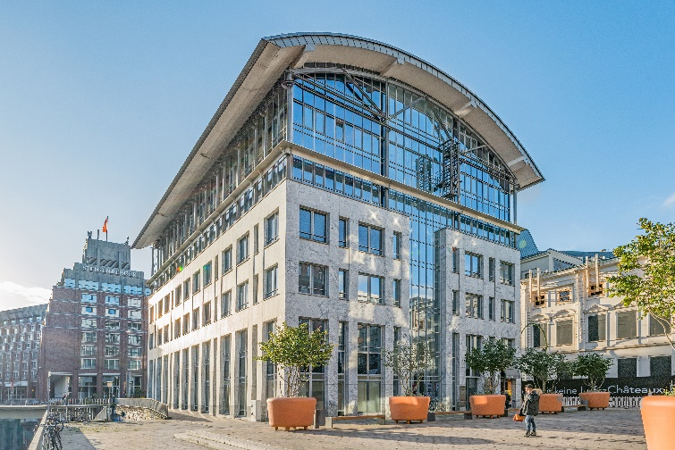 | Photo:  Grossmann & Berger facilitated Technogym Germany’s rental of 110 m² of shop space at Neuer Wall 77.  Source: Jörg Bucher / Grossmann & Berger GmbH

Please consult our website for Grossmann & Berger’s data privacy policy. Here you will also be able to access our press kit and the associated Terms of Use. If in future you would prefer not to receive any more information from our press office, please e-mail us at presse@grossmann-berger.de quoting as reference "Abmeldung aus Presseverteiler” / “Unsubscribe from press mailing list”.

