Hamburg: Letting of restaurant space in HafenCity
GOA Tandoori opens its third restaurant in Hamburg

Hamburg, 11 May 2022 – GOA Tandoori, which operates a restaurant in Blankenese and another in the “Stadthöfe” complex, has chosen HafenCity as the site for its third outlet. The company has taken some 208 m² of restaurant space at Grosser Grasbrook 9, located between the Magellan-Terrassen and the headquarters of Kühne + Nagel. On the ground floor is a patio measuring about 50 m² which offers an unobstructed view of the Elbphilharmonie concert hall. The space is located in the “Centurion Commercial Centre” owned by Union Investment Real Estate – a building completed in 2011 and awarded a DGNB certificate in platinum for environmental design and sustainability. This property forms part of the UniImmo: Deutschland fund. Grossmann & Berger, member of German Property Partners (GPP), brokered the rental agreement between GOA Tandoori and Union Investment Real Estate.

Cosy but modern
For GOA Tandoori it is especially important to create a cosy atmosphere in a modern setting. In addition to its authentic Indian specialities, the restaurant will be serving the “Grand Thalis à la Tapas”, a sharing plate with a selection of various Indian dishes. To round off the food menu, cocktails with a hint of Indian spices can be ordered.

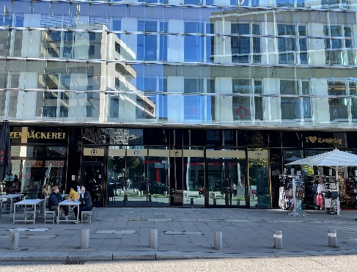 | Photo:  The spacious 50-square-metre patio at Grosser Grasbrook 9 can accommodate plenty of outdoor seating.  Source: Matthias Schücking / Grossmann & Berger GmbH

Please consult our website for Grossmann & Berger’s data privacy policy. Here you will also be able to access our press kit and the associated Terms of Use. If in future you would prefer not to receive any more information from our press office, please e-mail us at presse@grossmann-berger.de quoting as reference "Abmeldung aus Presseverteiler” / “Unsubscribe from press mailing list”.

