Hamburg: Office space let
Medical Assessment Service Medizinischer Dienst Nord moving into new ‘Billdeich’ building in 2026
Development creates a new gateway to Rothenburgsort

Hamburg, 3rd November 2022 – In the context of the urban development programme to move upstream along the Bille and Elbe rivers (‘Stromaufwärts an Bille und Elbe’) Hamburg’s Rothenburgsort district has been a focus of planning and one of the city’s most up and coming locations for quite some time. The ‘Billdeich’ project at Billhorner Deich 94-96, directly opposite the S-Bahn train station “Rothenburgsort” will form the attractive gateway to the district. The new-build offers 6,930 m² of office space and will serve both as Medizinischer Dienst Nord’s consulting and assessment centre (BBZ) and as their new headquarters. The move will affect some 300 employees. The Medizinischer Dienst Nord is responsible for giving advice and offering assessments in relation to benefits provided by the health and social or nursing care insurance schemes in Hamburg and Schleswig-Holstein. The offices in Schleswig-Holstein will not be moving. Grossmann & Berger, a member of German Property Partners (GPP), brokered the rental agreement in its capacity as exclusive lead broker for the owner, a Newport Holding real estate company.

Modern workplaces: flexible floor-plans, spaces that can be sub-divided
Since 1998 the Medizinischer Dienst Nord has occupied offices in one of the high-rise buildings at Berliner Tor, at the start of Hammerbrookstrasse. The move is necessitated by plans to completely redesign the Berliner Tor area. Thanks to attractive conditions at the new location, this corporation under public law can continue to spend funds collected from members of the statutory health and social or nursing care insurance schemes economically. Four storeys in the new-build offer individual offices, team spaces and multi-functional workspaces to suit requirements. The space can be divided up in many ways and, if less space should be required later, divided so that part can be let to another tenant.

New location: ideal transport links, set for the future
The planned ‘Billdeich’ office and commercial development is right on the edge of the ‘Billebogen’ urban development area. There is already one building on this site - which is directly linked with the public transport system via the “Rothenburgsort” S-Bahn train station – as well as a refurbished office and commercial block. These premises are used by the Hamburg Fire Service’s head office and the facilities service provider Kötter Services. It is planned that small artisan companies take space on the lower floors of the ‘Billdeich’, the four floors above these will be reserved for the offices of the Medizinischer Dienst. The building consists of 4 blocks joined to form an E with three interior garden courtyards and roof terraces on the set-back floors. Plans include an underground garage, a bicycle park and a charging station for e-vehicles. Completion is scheduled for the middle of 2023.

Type of use | Office space
City, district | Hamburg, Rothenburgsort
Projektname | ‚Billdeich‘
Straße | Billhorner Deich 94-96
Vermieter | Objektgesellschaft der Newport Holding GmbH
Mieter | Medizinischer Dienst Nord, Körperschaft des öffentlichen Rechts
Vermittler | Grossmann & Berger GmbH
Bürofläche | Ca. 6.360 m²
TG-Stellplätze | 50

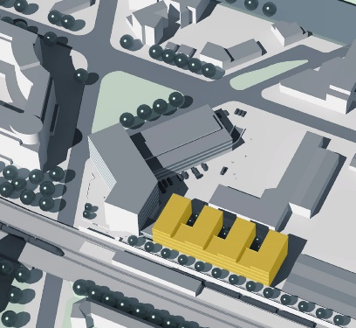 | Photo:  A Newport Holding real estate company is developing the office and commercial ‘Billdeich’ building at Billhorner Deich 94-96.  Source of image: florianfischötter_architekt
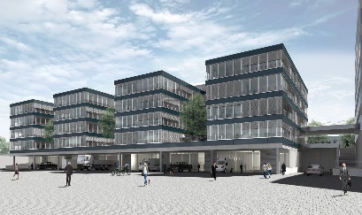 | Photo:  Medizinischer Dienst Nord is renting 6,360 m² of office space on the four upper floors of ‘Billdeich’.  Source of image: florianfischötter_architekt
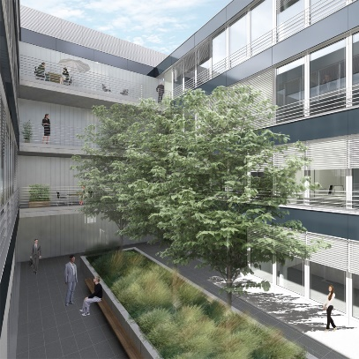 | Photo:  The building’s elements surround three garden courtyards.  Source of image: florianfischötter_architekt

About Grossmann & Berger
Grossmann & Berger GmbH is one of the leading service providers in the business of selling and letting commercial and residential properties in North Germany. Including its main office in Hamburg, the Company has 22 regional offices. This allows Grossmann & Berger to cover the entire North German market. In May 2021 the company was augmented by E & G Real Estate and
E & G Private Immobilien, so that Grossmann & Berger also operates in the two South German metropolitan areas of Stuttgart and Munich. Drawing on their comprehensive expertise in the real estate business, some 240 employees provide the full range of relevant services. They also benefit from the company’s more than 85 years standing in the industry. Grossmann & Berger belongs to the HASPA Group and is a founding member of the national commercial real estate network German Property Partners (GPP).

About NEWPORT HOLDING GmbH
NEWPORT HOLDING GmbH was founded in 2004 by Olaf Kunkat (CEO) and Manfred Schoenbach (Chairman) and is an owner-managed property developer and investor committed to sustainable real estate projects in Germany, the USA and Switzerland. The company invests in easily accessible locations in urban centres. Some of the focal points of investment in the USA are multi-family homes, offices and shop properties. In Germany NEWPORT is investing more heavily in commercial buildings and land. With branches in Atlanta, Berlin and Hamburg, the real estate investor covers the entire value chain from acquisition, development and planning to construction, letting and management. Further information is available here.

About Medizinischer Dienst Nord
Medizinischer Dienst Nord is the consulting and assessment service for Hamburg and Schleswig-Holstein. Originally the health insurer’s service was called Medizinischer Dienst der Krankenversicherung Nord (MDK Nord); it was reincorporated under a new name on 1st March 2021 to meet legal requirements. Previously, in 2006, the MDK services of Hamburg and Schleswig-Holstein had merged. The assessment personnel make their reports on the medical or nursing/care requirements of individual insured persons for the statutory health and social care insurance funds. In addition they inspect the services provided by hospitals, care homes and at-home carers. The Medizinischer Dienst Nord employs some 600 people in six locations.

Please consult our website for Grossmann & Berger’s data privacy policy. Here you will also be able to access our press kit and the associated Terms of Use. If in future you would prefer not to receive any more information from our press office, please e-mail us at presse@grossmann-berger.de quoting as reference "Abmeldung aus Presseverteiler” / “Unsubscribe from press mailing list”.

