Hamburg: Office letting
3D printer to make sneakers at former Rotring facility

Hamburg, 1 December 2021 – Zellerfeld R&D, a start-up founded in 2020 in New York, has a 3D sneaker-printing factory in Hamburg. Because the premises located on Stahltwiete are now too small, the company is moving to a different part of Bahrenfeld district, to Schnackenburgallee 41. Here the company has taken some 1,800 m² of office and manufacturing space on the fifth floor. The building on the Winsbergring industrial estate used to be a Rotring manufacturing facility for the production of the firm’s writing implements and is now owned by ImmoRex. Grossmann & Berger, member of German Property Partners (GPP), brokered the sub-letting agreement. The lead tenant is Buddy & Selly Reverse Retail.

When Rotring had left its manufacturing and office building in 2002 the four-storey structure was totally refurbished; two extra stories were added and four additional service cores created. In total the property now offers 17,500 m² of multi-purpose commercial space.

Zellerfeld R&D operates an online platform on which designers working all over the world can present their 3D shoe designs. Consumers can use the platform to have their chosen sneakers fitted, personalized and produced by 3D printer.

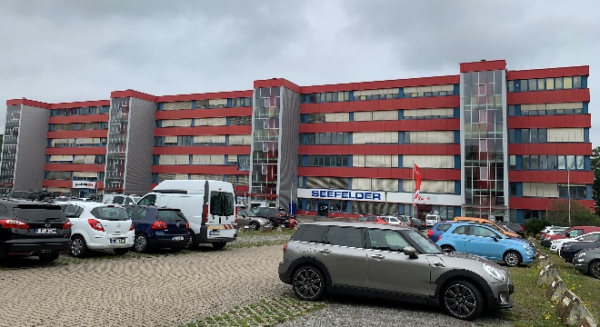 | Photo:  Acting on behalf of Zellerfeld R&D, a start-up from New York, Grossmann & Berger brokered the agreement for new premises at Schnackenburgallee 41 in Hamburg-Bahrenfeld in 2021.  Source of image: Grossmann & Berger GmbH

Please consult our website for Grossmann & Berger’s data privacy policy. Here you will also be able to access our press kit and the associated Terms of Use. If in future you would prefer not to receive any more information from our press office, please e-mail us at presse@grossmann-berger.de quoting as reference "Abmeldung aus Presseverteiler” / “Unsubscribe from press mailing list”.

