Hamburg: Industrial & logistics property let
Mac Baren Tobacco opens German headquarters in Hamburg

Hamburg, 16 March 2022 – Mac Baren Tobacco from Denmark is setting up its headquarters for Germany at Usedomstrasse 7-9 in the Wandsbek district of Hamburg. Mac Baren Tobacco, Scandinavia’s largest privately-owned tobacco company, is to occupy premises offering 1,510 m² of manufacturing space, warehousing and offices. The search for a location led Mac Baren Tobacco Germany to Grossmann & Berger, a member of German Property Partners (GPP). The real estate services provider had been granted an exclusive commission by the private owner to find a tenant for his property.

Bringing the brands together
In 2019 Mac Baren Tobacco took over the Planta portfolio of brands, directing sales of these products from a base at the Unitas Tabakfabrik in Berlin; now, however, sales, marketing, warehousing and logistics are to be moved in stages to Hamburg. From July onwards, the entire Mac Baren Tobacco portfolio of brands will be integrated into the new headquarters’ sales department. “I am looking forward to building a new sales and logistics team in Hamburg,” says Sebastian Clausen, managing director of Mac Baren Tobacco Germany. “Hamburg is an ideal location because it is close to our head office in Svendborg, Denmark.”

New headquarters building is a gem
Covering 2,180 m² the site is on the industrial estate Am Stadtrand/Tilsiter Strasse, between Friedrich-Ebert-Damm (a.k.a “Car dealer alley”) and Walddörferstrasse. Directly served by two bus routes, it is easily accessible for employees and customers alike. Moreover, there are ten outside parking spaces on site. “A commercial property like this one is a rare find in Hamburg,” explains Bertram Schubert. The Grossmann & Berger consultant for industrial and logistics properties brokered the rental agreement. “The facility was built in 2011 and to date it has been used as a photo studio. The owner displayed great foresight in planning the building and ensured that it could be repurposed for use by a different kind of enterprise.” Apart from its attractive architectural design, the building has an imposing entrance and lobby area and is equipped with state-of-the-art technical services. The outside area is fully enclosed by a fence, the manufacturing area has no additional supports and the hall can be divided into three sections with partition curtains.

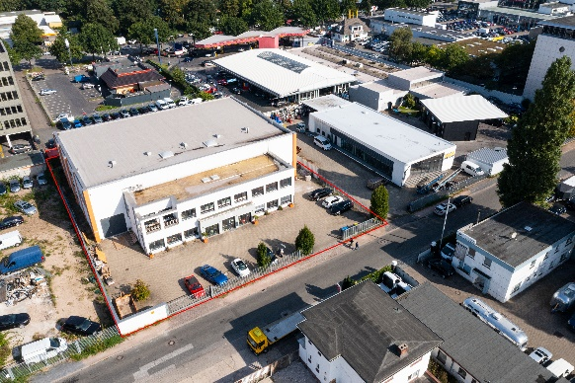 | Photo:  Mac Baren Tobacco is setting up its new headquarters for Germany at Usedomstrasse 7-9 in Hamburg-Wandsbek.  Source: Private owner
Photo:
Until now, the commercial property at Usedomstrasse 7-9 was used as a photo studio. The turntable in the hall has already been dismantled.

Source: Private owner

Please consult our website for Grossmann & Berger’s data privacy policy. Here you will also be able to access our press kit and the associated Terms of Use. If in future you would prefer not to receive any more information from our press office, please e-mail us at presse@grossmann-berger.de quoting as reference "Abmeldung aus Presseverteiler” / “Unsubscribe from press mailing list”.

